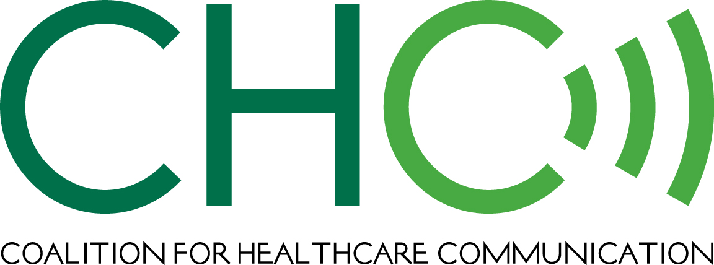

Division of Drug Information
Center for Drug Evaluation and Research
Food and Drug Administration
10903 New Hampshire Ave.
Building 51, Room 2201
Silver Spring, MD 20993

Submitted by email

April 8, 2014

RE: Docket No. FDA-2013-N-1430

RE: Draft Guidance for Industry on Fulfilling Regulatory Requirements for Postmarketing Submissions of Interactive Promotional Media for Prescription Human and Animal Drugs and Biologics

The Coalition for Healthcare Communication (CHC) appreciates the opportunity to file comments and make recommendations regarding the draft guidance on postmarketing submissions of interactive promotional media.

CHC applauds the FDA’s efforts in developing this draft guidance and particularly supports the agency’s very reasonable position that drug companies are not responsible for independent media and content that is not under their control. This position allows sponsors to provide unrestricted grants for media and content that will enhance and improve the knowledge and awareness levels of both healthcare professionals and consumers. Further, CHC supports the flexibility being recommended for Form 2253 and Form 2301 reporting, because it believes such flexibility will boost efficiency for industry and for FDA.

Below, CHC has addressed several issues and concerns that are of particular interest to its member companies. If FDA would like further clarification of our comments on any of these areas, CHC and its members would be pleased to work with the agency as needed. CHC believes that further refinement of the important issues outlined here will improve the clarity of the draft guidance’s provisions and advance the goal of industry submitting interactive promotional media to FDA for their products when meaningful and appropriate.

Factors Considered in Determining Postmarket Submission Requirements for Interactive Promotional Media

In this section of the draft guidance, FDA states that “a firm is responsible if it exerts influence over a site in any particular, even if the influence is limited in scope” and gives as an example of this influence a firm that “collaborates on or has editorial, preview, or review privilege over the content provided.”

The question of how influence or “control” is defined for the purposes of this guidance is perhaps the most important one to medical publishers, agencies and life science companies. In particular, it appears the FDA is defining control to include company influence over the placement of advertising – a common practice in all advertising, including print, broadcast and online advertising.

For broadcast ads, for example, a firm may state it does not want its ad opposite a competitor’s ad or within certain types of programming, and/or it may state that it is seeking a certain demographic for its advertising. However, those ad placement parameters – while they exercise control over where the ad will run – do not change or control anything about the surrounding content. If the FDA is asserting that sponsors have control over the content simply by selecting the editorial content most appropriate for the advertising, it makes virtually all media buying an exercise in control, and thus renders all of the material on sites the responsibility of the advertiser from the point of view of FDA.

If this provision stands, it could not only affect online/social media advertising practices but also migrate into the buying of all media, an unfortunate result for FDA and generally accepted media practice and journalism ethics. Indeed, the common journalism ethic in legitimate media, including mainstream medical journal and consumer sites, is to have a virtual Chinese wall between editorial content and advertising. This is an ethics and journalism convention that serves all media, the FDA and the public, because it protects against hidden advertising and hidden advertiser influence on editorial content. Advertising placement does not affect this, but only enables the advertiser to select the editorial content most appropriate for the advertising and most likely to draw the desired audience.
Under current FDA off-label policies, FDA sometimes may have a legitimate interest in advertising placement decisions by regulated companies, e.g., placement in areas where only off-label prescribers are present. In this regard, we note that medical publishers generally do not allow product ads to run adjacent to related editorial content. In any case, sponsor placement does not undermine the editorial independence of the medium and should not be used by FDA to deem the sponsor in control of the content. Moreover, where FDA has a regulatory interest, FDA has sufficient authority to investigate such placements without invoking a “placement constitutes control”-based guidance.
In addition, if FDA proceeds according to the draft guidance, it will be receiving hundreds – and maybe thousands – of Form 2253 submissions that could overwhelm its capacity to review and might end up inhibiting – not facilitating – good FDA marketing review practice.
Some of our members also are concerned that under a broad interpretation, “collaborates on” could mean that a firm cannot hold public relations workshops for any media that it supports with advertising or unrestricted educational grants. If this were the case, any PR department assistance in the development of a story – e.g., even connecting a New York Times reporter with the appropriate spokesperson for a particular issue or providing background information on a topic – could conceivably be covered under this provision. Is it the FDA’s intention that if these PR activities were to occur, a company would be obligated to file a 2253 and provide a copy of the related article to the agency? We don’t think so, but believe the FDA should clarify this point, because this interpretation would chill the practice of companies speaking to the media, which certainly cannot be the outcome the agency intends.

CHC believes that there needs to be a crystal clear definition of what companies are responsible for and what they are not responsible for; without this clear line, companies are likely to err on the side of oversubmission, which inevitably will result in FDA receiving a flood of documentation and paperwork it will have to wade through to determine which 2253s are meaningful and which are not meaningful.

This section of the draft guidance (Line 130) also includes a provision stating that “Under certain circumstances, a firm is responsible for promotion on third-party sites” if it has “any control or influence on the third-party site, even if that influence is limited in scope.” Again, if companies are not responsible for the content, it seems counterintuitive that they should have to submit that content with a 2253.

It is worth noting that if the FDA takes this tack, there may be unforeseen consequences. For example, because sponsors are not accustomed to submitting 2253s for materials they do not own and take responsibility for, firms may back away from reviewing whether a particular online venue is an appropriate place for its messaging, which could lead to less – not more – responsible placement of materials.

The draft guidance also states that if a firm “provides only financial support (e.g., through an unrestricted educational grant) and has no other control or influence on that site, then the firm is not responsible for information on a third-party site, and has no obligation to submit the content to FDA” (Lines 136-139). Some of our members seek more clarity on whether data monetization revenues that fund otherwise independent user-generated content are considered the type of financial support that is exempt from submission.

The FDA also states in the guidance (Line 150, etc.) that firms must submit their promotion, “along with the surrounding pages, to adequately provide context to facilitate the review of a third-party site.” Media teams contend that this request is virtually impossible to comply with because they do not have access to the final content even if they are directing ad placement. This scenario is exponentially problematic in the context of paid searches, where placement is suggested by the purchase of keywords but the surrounding organic results can be different from minute to minute and from user to user. Additionally, media buys today are happening in real time – with ongoing evaluation, analysis and ad placement happening continuously. Does the FDA intend to require a new 2253 submission every time a firm reuses the same ad in a new location? This would be unwieldy and greatly hinder ad placement.

Even if firms attempt to review and submit any and all materials that run near their ads – a substantially different standard than those applied for other media – and include every page on which their banner ad may run, the situation could become untenable if the publication decides after the 2253 has been submitted to change a page or amend editorial content. The other logistical questions that our members raise regarding this section are:

(1) Precisely how would firms submit the online pages on which their ads are running?
(2) At what point would they submit the materials, because the advertiser does not necessarily have the final content when placement occurs?
(3) If the FDA is calling for the submission of content that the company controls and content that the company does not control, how would a company delineate or annotate which materials are “theirs” and which content is not their responsibility?

The draft guidance also states (Line 160) that “a firm is responsible for the content generated by an employee or agent who is acting on behalf of the firm to promote the firm’s product.” This statement raises a question regarding whether a key opinion leader (KOL), agent or employee acting independently of the firm is presumed to be acting on behalf of the firm. For example, it would be helpful if FDA could clarify whether all social media participation by a marketing agency, KOL or employee is considered content controlled by the firm.

Further, as we read the guidance, if a firm moderates its site by editing or deleting posts or content, those actions render it responsible for all the user-generated content on the site. Firms that moderate sites do so to practice brand stewardship and to ensure that any recommendations made on blog are not dangerous. It seems that a policy taking away the freedoms granted for UGC for firms that moderate their sites is not what the agency intended.

Recommendations for Submitting Interactive Promotional Media

The draft guidance states in this section (Line 246) that “once every month, a firm should submit an updated listing of all non-restricted sites for which it is responsible or in which it remains an active participant and that include interactive or real-time communications” and that this provision can be satisfied with the site name, URL and date range for exchanges for which the firm is an active participant. However, FDA should consider that firms may not wish to take responsibility for entire URLs (e.g., an employee’s Facebook page) and may wish only to submit monthly the distinct material where product/promotional content is discussed. We are seeking further guidance regarding whether this approach is acceptable under the guidance.

We also seek clarification regarding how FDA is defining “publicly accessible” sites. The draft guidance states that publicly accessible sites are those that do not have restrictions, such as a password or subscription. Does this statement mean that Facebook and Twitter, which are often password-protected by the users, are not included in this category? Or does FDA mean to imply a higher level of protection/limits to access?

For restricted sites, instead of imposing broad submission requirements that could generate a significant number of submissions to the agency, the FDA may want to contemplate the same level of regulation for restricted sites as available to non-restricted sites, with the stipulation that restricted sites grant to FDA limited audit rights to access these sites to review non-independent submissions made by firms. We are not certain if this FDA audit option would have a negative effect on the use of restricted sites, but it may be worth considering in lieu of overly burdensome reporting requirements.

Again, the Coalition for Healthcare Communication appreciates this opportunity to comment on these matters and stands ready to offer additional information at your convenience.

Sincerely,

John Kamp
Executive Director
Coalition for Healthcare Communication

